St. Gregory’s Newsletter
9th April 2017 Palm Sunday Parish Mass Book page 176
The Parish Office is staffed on Monday, Wednesday and Friday from
9.00am to 13.00pm.

Website www.stgregoryschorley.org.uk
Telephone 01257 262462
e-mail stgregorys.weldbank@btinternet.com

Archdiocese of Liverpool Registered Charity
No. 32709

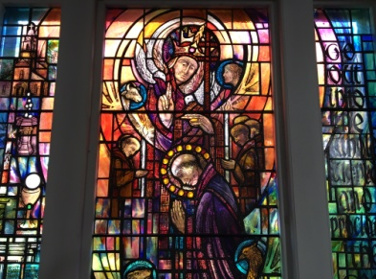

The Blessings of Holy Week

Give to us, Lord,
The blessings of this Holy Week,
As we walk with you in the footsteps of your passion.

Give to us, Lord,
The blessing of overcoming cowardice and fear and embracing
Sacrifice and commitment.

Give to us, Lord,
A greater love for you,
Even as you hang on the cross, feeling deserted by heaven and shunned by earth.

Give to us, oh Lord,
A greater love for one another,
That with you among us we may be instrumental in your work of redemption
and bring healing and peace to our world.

Adapted from ‘Walk With Me’ A Lenten Journey
Alive Publishing 2017

The Servant King

Today we enter Holy Week.
As we enter church we will be given a palm, often in the shape of a cross. Palm Sunday marks Jesus’ triumphal entry into Jerusalem when the crowds littered his path with palm fronds. They asked, ‘Who is this?’ (Matthew 21:10)
We are asked the same question. How do we answer? We confess with our hearts and proclaim with our words that this is Jesus of Nazareth, the Servant King, who, being in very nature God did not consider equality with God something to be grasped.
He made himself nothing, taking the very nature of a servant, being made in human likeness.
Jesus is God made man, he humbled himself and became obedient to death, even death on a cross.
(Philippians 2:6-8)
May we follow his example in being obedient to the will of God in our lives.

[Type a quote from the document or the

Children’s Corner
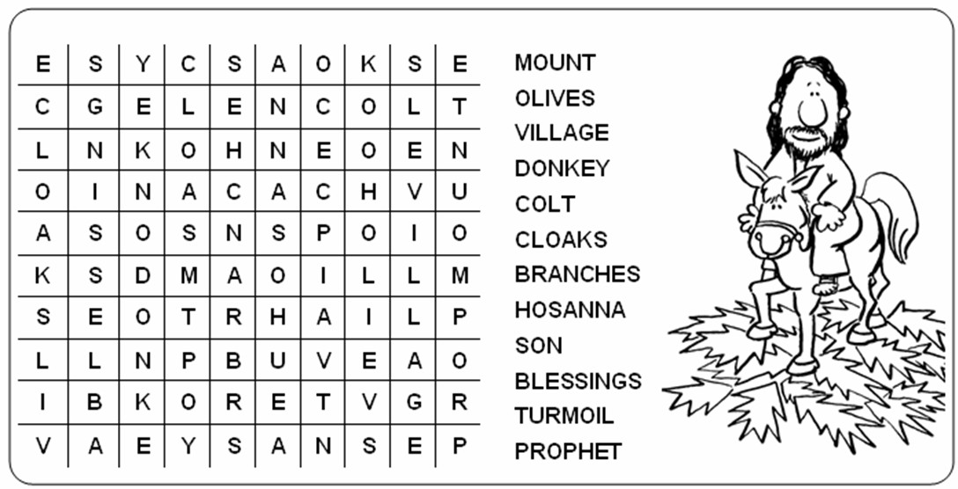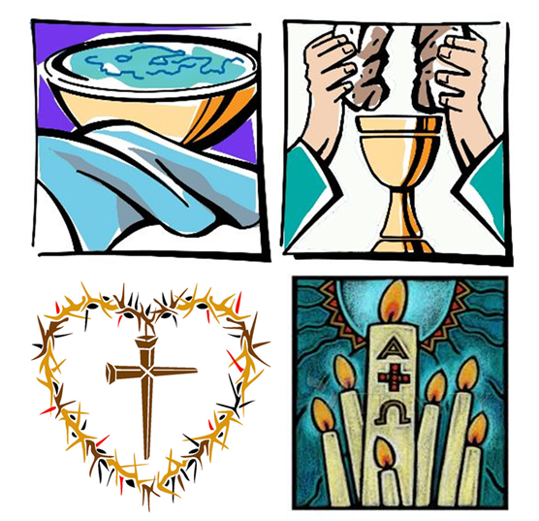
Palm Sunday - 9th April 2017

Palm Sunday 9th April Easter Sunday 16th April
9:30am Frank Smith 9:30am The Parish
11:00am Peter Evans (A) 11:00am Leon Dickinson (RIP)
6:30pm Oswald Corcoran (A) 6:30pm NO MASS
3:00pm Service of Reconciliation

Weekday Masses
Monday 7:30am William Calland
Tuesday 8:30am Frank Smith
Wednesday 8:30am Jack Simmonds
Thursday 7:30pm The Mass of the Lord’s Supper - Jack Critchley, RIP (would have been 100th B’day)
Friday 3:00pm The Celebration of the Lord’s Passion
Saturday 8:15pm The Easter Vigil - Easter List

Weekly Confession NO CONFESSION Rosary 20 minutes before weekday Mass

Please Pray For Our Sick Brothers And Sisters
Kitty Ellison, Jayne Hodge, Kathleen Reynolds, Brigid Cain, Mary Patten, Agnes Martindale, Robert Stretton, Mildred Bridge, Margaret Wood, Harold Sutton, Margaret Bower, Thomas Moss, Gerard Baker, Hugh Daly, Margaret Dearden, Maureen Jackson, Maureen McIver, Bill Burns, Lois Chiasson, Gerard McGuigan, Moya Jones, Teresa Kershaw,Teresa Critchley,Canon Richard Firth

Sadly we announce the death of Marian Holding on 2nd April. Her funeral service will be held on 20th April. May she rest in peace.

Baptism today
Congratulations to George Oscar Witkiss who will be baptised today. Please keep him and his family in your prayers as they start on their faith journey together.

Wedding Bells
Congratulations to Leanne and Richard Chartier who got married here yesterday. May they enjoy God’s blessings in a long, happy and fruitful life together.

Collections
Thank you for last week’s collection of £1051. And thank you for your generosity also at the Lenten Family Fast Day collection which raised £940 for CAFOD.

East Africa Crisis Appeal
£303 has been donated and sent to CAFOD. Sincere thanks for your gift to the poorest of the poor.

Lenten Services of Reconciliation
A Service of Reconciliation will take place today at St Gregory’s at 3pm, individual confessors will be on hand.
There will also be services during the week at St Mary’s, Monday 7pm & Sacred Heart, Tuesday 7pm. Please remember that this is a sacrament of God’s love & mercy and is not to be feared.

Lenten Alms
Last chance! Donations will go to the Nugent Care Society, for sick and vulnerable people in our Archdiocese.

Good Friday Ecumenical Walk of Witness
The Christian Churches in Chorley traditionally unite for a walk of witness to the world that Jesus has redeemed us through his cross and resurrection, and that we are his followers. This year it will start at 11:30am at St. Laurence Church and finish around 12:00pm with a short service of prayer at St. Mary’s. All are most welcome to take part in this ecumenical event.

Easter List
If you would like someone remembered at the Vigil Mass please pass the names in at the office. Any donations will be sent to Nugen Care. Thank you.

The Catenian Society
Bill Critchley would like to thank all who supported the recent Catenian Charity event by their attendance or donations. £1000 has been sent to the Friends of the Holy Land who work to assist struggling Christian communities in Palestine.

On Sunday 9th April Terence Donnelly will be installed as the next President of the Catenian Association in the Chorley area. This international group of proudly Catholic laymen who are committed to their faith, their families and to those in need may have something to offer you. If you would like to know, please contact them either here at Church or online at www.thecatenians.com .

Ministering to the Assembly
Counters 10th April, Eileen Snape & Rita McIntyre
Rotas 16th April, Easter Sunday
S.A.S. Mary Wakeman & Liz Fowler
Dial a Ride Phil Southworth & Bernard Hargreaves
Readers Christine Crossen Sara Norse NO MASS
Euch. Ministers Richard Jackson Barbara Slater
Clare Meredith Denise Conway
Margaret Scard Sharon Hobin

