St. Gregory’s Newsletter
14th May 2017 Fifth Sunday of Easter Parish Mass Book pg. 265
The Parish Office is staffed on Monday, Wednesday and Friday from
09.00 to 13.00.

Website www.stgregoryschorley.org.uk
Telephone 01257 262462
e-mail stgregorys.weldbank@btinternet.com

Archdiocese of Liverpool Registered Charity
No. 32709

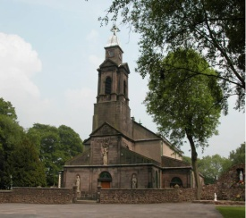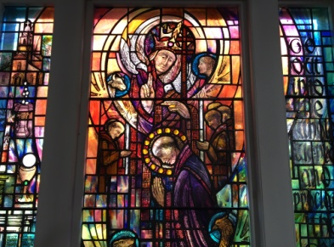

REFLECTION
Deacons.
In the hierarchy of the Catholic Church, you have bishops, priests, and deacons. Catholics recognize two types of deacons:
Permanent deacons are men ordained who normally have no intention or desire of becoming priests. He can be single or married. If the latter, he must be married before being ordained a deacon. If his wife dies before him, he may be ordained a priest if the bishop permits and approves.
Permanent deacons, especially those who are married, have secular jobs to support their families and also help the local community by visiting the sick, teaching the faith, counselling couples and individuals, working on parish committees and councils, and giving advice to the priest and is often a link between parishioners and priest.
Transitional deacons are seminarians, students in the last phase of training for the Catholic priesthood. After being a deacon for a year, they’re ordained a priest.

All deacons can baptize, witness marriages, perform funeral and burial services outside of Mass, distribute Holy Communion, preach the homily (which is the sermon given after the Gospel at Mass.

You may remember the Archbishop writing to say how important the role of the deacon was within the church and asking for men over 35 to consider whether they had a vocation to it. So if you are in that category have you?
For more information see Fr Graeme. Pray for our deacons.

Saint of the Week
Saint Dunstan
Dunstan was born near Glastonbury in 909, and died in Canterbury on this day in 988. He studied secular arts and literature before becoming a monk, then abbot, at Glastonbury. He was the principal agent in the restoration of English monasticism after the Viking devastations. In rapid succession, he became bishop of Worcester, bishop of London, and Archbishop of Canterbury. A man of many talents, he was renowned as a painter, musician, and worker in metals, besides being a counsellor of kings and a zealous
reforming bishop.
Until Thomas a Becket
later eclipsed Dunstan's
fame he was the most
popular English saint.

[Type a quote from the document or the

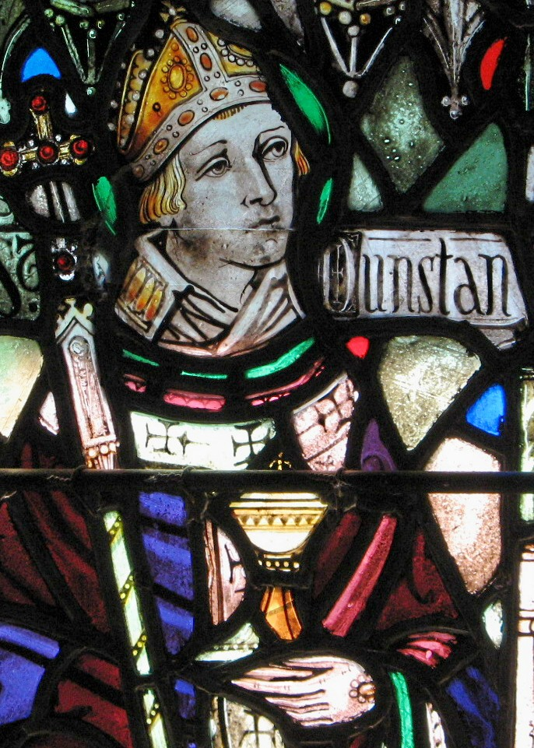

https://tse4.mm.bing.net/th?id=OIF

Children’s Corner

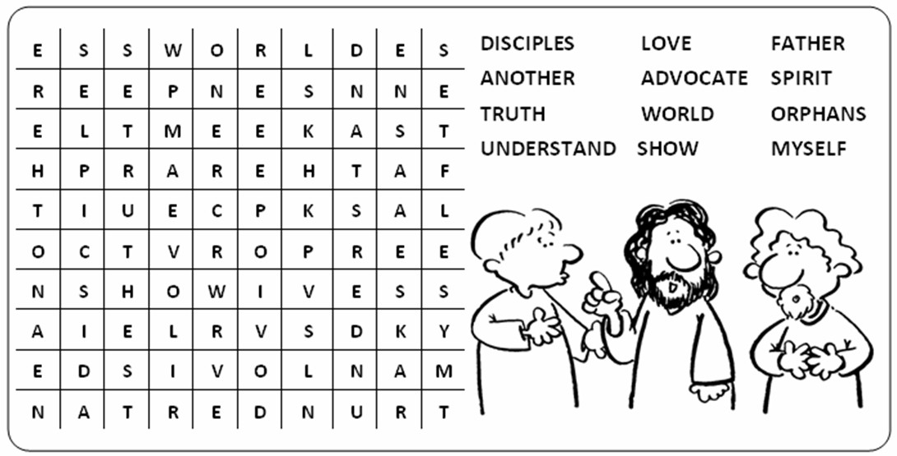
5th Sunday of Easter 14th May 2017

5th Sunday of Easter 6th Sunday of Easter, 21st May
9:30am Joseph Robinson 9:30am Julie Houghton
11:00am Thanksgiving to our Lady of Lourdes/St. B. (DC) 11:00am Gerald & Teresa Thompson
6:30pm Tom Wilcock 6:30pm Farnworth Family
Weekday Masses Saints of the Week
Monday 8:30am John Farnworth (FM) Our Lady of Fatima
Tuesday 8:30am Kathleen Reynolds (B 100yrs!)
Wednesday 8:30am Maureen Hall
Thursday 8:30am Valerie Bretherton St. John I
Friday 8:30am William Mulhearn St. Dunstan
Saturday 10:00am Rita Threlfall (A) St. Bernadine of Siena

Weekly Confession Saturday after morning Mass Rosary 20 minutes before weekday Mass

Please Pray For Our Sick Brothers And Sisters
Kitty Ellison, Jayne Hodge, Kathleen Reynolds, Brigid Cain, Mary Patten, Agnes Martindale, Robert Stretton, Mildred Bridge, Margaret Wood, Harold Sutton, Margaret Bower, Thomas Moss, Gerard Baker, Hugh Daly, Margaret Dearden, Maureen Jackson, Maureen McIver, Bill Burns, Lois Chiasson, Gerard McGuigan, Moya Jones, Teresa Kershaw, Teresa Critchley, Winifred Calderbank

Gold Medal:
Congratulations to David Critchley who is/has received the altar servers gold medal today in recognition of his long service and the guidance he has given to many generations of altar servers. May God bless him and his important ministry in the parish.

Children’s Liturgy
Today we welcome the children preparing for their first Communion at the 11am Mass. They will have a ‘get together’ in the church house after mass.

Baptism
We welcome in Baptism today Layla Mae Catterall and wish her and her family every blessing on their new Faith journey.

Collection
Thank you for last week’s collection of £852.92. (not including SO’s & DD’s)
Thank you also for the collection for the Priests Training Fund which came to £438.06
We also raised £1036.14 from the Lent Family Fast Day & £303 for the East Africa Crisis Appeal both were sent to CAFOD
God bless you for your generosity.

A Historical Find !
St. Catherine’s Hospice bookshop received a lot of books from a house clearance in Chorley and found a Baptism Certificate dated 4th September 1892! The name on it appears to be Harold Baxendale – does anybody have any connection with him, as a great-grandfather perhaps? You are welcome to the certificate, it is kept in the sacristy.

Ministering to the Assembly

Counters 15th May, David Chadwick and Pauline Turner

Rotas 21st May, 6th Sunday of Easter

S.A.S. Margaret Scard
Dial a Ride Tommy McGuigan and Paul Thompson
Readers Pauline Doyle Dominic Stone John Oswell
Euch. Ministers Margaret Scard Denise Conway TBA
Linda Walmsley Helen Mather
Edward Brierley Paul Thompson

